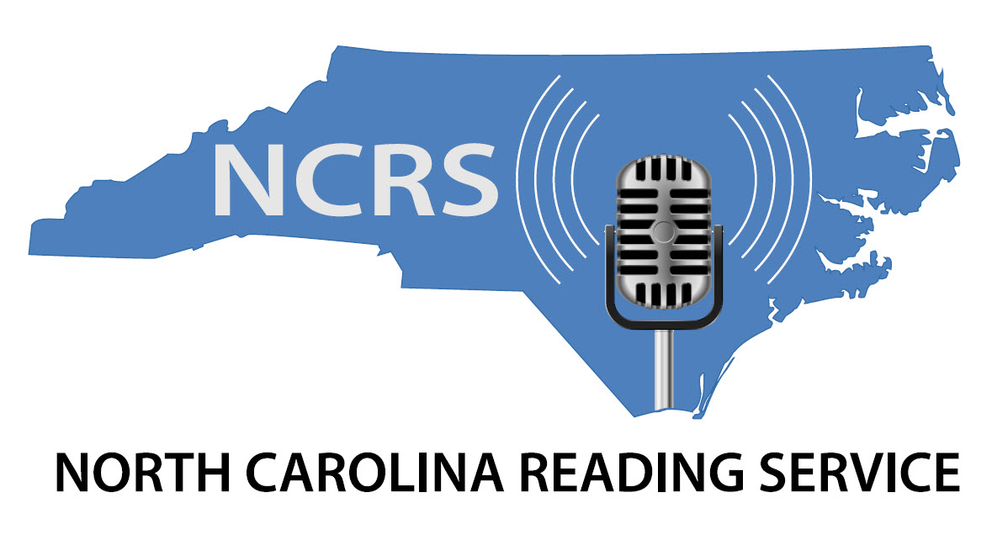

**PROGRAM GUIDE**

**211 East Six Forks Road, Suite 103**

**Raleigh, NC 27609**

**(919) 832-5138**

We breathe words into your life. Since 1983!!

**Explanation of Symbols Used**

Triangle Radio Reading Service brings you current news and information 24/7. Wall Street Journal is aired by “Massachusetts Talking Information Center”.

Programs received from other services are indicated with an asterisk (*). Programs that are rebroadcast are indicated with **(R)**.

***CONNECTIONS***

*Connections* airsthe following monthly schedule on Tuesdays at 2:00 pm

1ST Tuesday – Tech Tips

2nd Tuesday – Triangle YesterYear

3rd Tuesday – Education Today

4th Tuesday – Legal Matters

5th Tuesday – TBA

***EXPLORE***

*Explore* airs the following monthly schedule on Tuesdays at 2:30 pm

1st Tuesday – Read to Succeed

2nd Tuesday – Discover Magazine

3rd Tuesday – Connect to Success

4th Tuesday – All about Pets

5th Tuesday – TBA

***SPECIAL EDITION***

*Special Edition* airs the following monthly schedule on Tuesdays at 4:00 pm

1st Tuesday – Poetry

2nd Tuesday – Community Connections

3rd Tuesday – Walter Magazine

4th Tuesday – That’s a Laugh!

5th Tuesday – TBA

***INDEPENDENT LIVING***

*Independent Living* airs the following monthly schedule on

Tuesdays at 8:30 pm

1st Tuesday- Science Fiction

2nd Tuesday-Movie/Theatre Reviews

3rd Tuesday- Heard Any Good Books Lately?

4th Tuesday- NC Museum History

5th Tuesday- TBA

***RESOURCE AND RECREATION***

*RNR* airs the following monthly schedule on Wednesday at 1:30 pm

1st Wednesday – Flavor

2nd Wednesday – Salute A Veteran Every-SAVE

3rd Wednesday – Reminisce Magazine

4th Wednesday – Lion Magazine

5th Wednesday – TBA

***POTPOURRI***

*Potpourri* airs the following monthly schedule Wednesdays at 4:00 pm

1st Wednesday – Nutrition News

2nd Wednesday – Restaurant Reviews

3rd Wednesday – Thought for Food

4th Wednesday – Movie/Theatre Reviews

5th Wednesday – TBA

Some programs may be rescheduled or replaced according to availability.

**Monday**

12:00 **Bookshelf Lite (R)**

1:00 **Reflections from the Past (R)** /**Independent Living(R)**

2:00 **Special Edition/Audio Description Program (R)**

3:00 **Oprah (R)**

4:00 **Triangle Business Journal (R)**

5:00 **Classics (R)**

6:00 **TIME Magazine (R)**

7:00 **Out in the Garden (R)**

7:30 **Smithsonian (R)**

8:00 **Wall Street Journal \***

9:00 **Get Fit \***

9:30 **News & Observer: State & Local News, New Bern Sun Journal, Greenville Daily Reflector, and Wilmington Star News**

11:30 **Drug & Department Store Ads**

Noon **Sports, Arts & Living, Wake Weekly, Washington Daily, Carteret News, Greensboro News & Record, and Winston-Salem**

1:30 PM **Armchair Traveler (R)**

2:00 **Independent (R)**

3:00 **New Yorker (R)**

4:00 **Ladies Magazine/Mystery Stories**

5:00 **News & Observer (R)**

6:30 **Independent (R)**

7:00 **USA Today**

8:30 **Drug & Department Store Ads (R)**

9:00 **Reflections from the Past (R)**

9:30 **Resource and Recreation (R)**

10:00 **Ebony/Religion in the News (R)**

11:00 **Vanity Fair II**

**Tuesday**

12:00 **Triangle Business Journal (R)**

1:00 **New Yorker (R)**

2:00 **Reflections from the Past (R)**

2:30 **Resource and Recreation (R)**

3:00 **Ebony (R)/ Religion in the News (R)**

4:00 **Ladies Magazine (R)**

4:30 **Mystery Stories (R)**

5:00 **Bookshelf Lite (R)**

6:00 **Take My Arm (R)**

7:00 **Drug & Department Store Ads (R)**

7:30 **Sports Illustrated for Kids (R)**

8:00 **Wall Street Journal \***

9:00 **Get Fit \***

9:30 **News & Observer: State & Local News, New Bern Sun Journal, Greenville Daily Reflector, and Wilmington Star News**

11:30 **Our State Magazine**

Noon **Sports, Chatham County News, Courier-Times, Washington Daily, Kinston Free Press, Jacksonville Daily, Greensboro News & Record, and Winston-Salem Journal**

1:30 PM **Money Matters (R)**

2:00 **Connections/Explore**

3:00 **Reader’s Digest**

4:00 **Special Edition/Atlantic Magazine**

5:00 **News & Observer (R)**

7:00 **USA Today**

8:30 **Independent Living**

9:00 **Sports in North Carolina**

9:30 **Vision News**

10:00 **Bookshelf Lite (R)**

11:00 **Vanity Fair II (R)**

**Wednesday**

12:00 **Armchair Traveler (R)**

12:30 **Vision News (R)**

1:00 **Literary Hour (R)**

2:00 **Independent (R)**

3:00 **Oprah (R)**

4:00 **Sports in NC (R)**

4:30 **Money Matters (R)**

5:00 **Classics (R)**

6:00 **Take My Arm (R)**

7:00 **Connections (R)**

7:30 **Drug & Department Store Ads (R)**

8:00 **Wall Street Journal \***

9:00 **Get Fit \***

9:30 **News & Observer: State & Local News, New Bern Sun Journal, Greenville Daily Reflector, and Wilmington Star News**

11:30 **Grocery Ads**

Noon: **Sports, Food & Dining, Carolinian, Washington Daily, Greensboro News & Record, and Winston-Salem Journal**

1:30 PM **Resource and Recreation**

2:00 **Children Story Hour**

3:00 **Modern Maturity**

3:30 **Smithsonian Magazine**

4:00 **Potpourri/Out in the Garden**

5:00 **News & Observer (R)**

7:00 **USA Today**

8:30 **Grocery Ads (R)**

9:00 **TIME Magazine**

10:00 **Classics (R)**

11:00 **Independent Living (R)/Vision News (R)**

**Thursday**

12:00 **Take My Arm (R)**

1:00 **Potpourri (R)/Out in the Garden (R)**

2:00 **TIME Magazine (R)**

3:00 **Modern Maturity (R)**

3:30 **Smithsonian Magazine (R)**

4:00 **Ebony (R)/Religion in the News (R)**

5:00 **Reader’s Digest (R)**

6:00 **Special Edition/Atlantic Magazine (R)**

7:00 **Connections (R)**

7:30 **Sports in North Carolina (R)**

8:00 **Wall Street Journal \***

9:00 **Get Fit \***

9:30 **News & Observer: State & Local News, New Bern Sun Journal, Greenville Daily Reflector, and Wilmington Star News**

11:30 **Health Issues**

Noon **Sports, Cary News, Johnston County Report, Washington Daily, Kinston Free Press, and Jacksonville Daily, Greensboro News & Record, and Winston-Salem Journal**

1:30 PM **Mystery Stories (R)**

2:00 **Literary Hour**

3:00 **The Week Magazine**

4:00 **Bookshelf**

5:00 **News & Observer (R)**

7:00 **USA Today**

8:30 **Health Issues (R)**

9:00 **Did You Know**

10:00 **Sports Illustrated for Kids**

10:30 **Teen Magazines**

11:00 **Our State Magazine (R)**

11:30 **Modern Maturity (R)**

**Friday**

12:00 **Literary Hour (R)**

1:00 **Did You Know (R)**

2:00 **The Week Magazine (R)**

3:00 **Potpourri (R)/Out in the Garden (R)**

4:00 **Bookshelf (R)**

5:00 **Reader’s Digest (R)**

6:00 **Health Issues (R)**

6:30 **Explore (R)**

7:00 **Connections (R)**

7:30 **Grocery Ads (R)**

8:00 **Wall Street Journal \***

9:00 **Get Fit \***

9:30 **News & Observer: State & Local News, New Bern Sun Journal, Greenville Daily Reflector, and Wilmington Star News.**

11:30 **Triangle Bulletin Board**

Noon **Sports, “Weekend” section of the News & Observer, Franklin Times, Washington Daily, Greensboro New & Record, and Winston-Salem Journal**

1:30 PM **Music Review**

2:00 **New Yorker**

3:00 **Oprah Magazine**

4:00 **Independent**

5:00 **News & Observer (R)**

7:00 **USA Today**

8:30 **Triangle Bulletin Board (R)**

9:00 **Money Matters**

9:30 **Modern Maturity (R)**

10:00 **Sports Illustrated for Kids (R)**

10:30 **Teen Magazines (R)**

11:00 **Independent (R)**

**Saturday**

12:00 **Triangle Bulletin Board (R)**

12:30 **Music Review (R)**

1:00 **Triangle Business Journal**

2:00 **New Yorker (R)**

3:00 **Independent (R)**

4:00 **Ebony (R)/Religion in the News (R)**

5:00 **Did You Know? (R)**

6:00 **Bookshelf (R)**

7:00 **Vision News (R)**

7:30 **Explore (R)**

8:00 **Children’s Story Hour (R)**

9:00 **Get Fit \***

9:30 **News & Observer: State and Local News**

11:00 **Ladies’ Magazines (R)**

11:30 **Music Review (R)**

Noon: **Que Pasa**

1:00 PM **Triangle Business Journal (R)**

2:00 **Bookshelf Lite**

3:00 **Potpourri (R)**

3:30 **Out in the Garden (R)**

4:00 **The Week Magazine (R)**

5:00 **Special Edition/Atlantic Magazine (R)**

6:00 **Classics**

7:00 **Oprah Magazine (R)**

8:00 **Literary Hour (R)**

9:00 **Qué Pasa (R)**

10:00 **New Yorker (R)**

11:00 **Vanity Fair I**

**Sunday**

12:00 **Triangle Bulletin Board (R)/Music Review (R)**

1:00 **Our State Magazine (R)/Potpourri (R)**

2:00 **Oprah (R)**

3:00 **Classics (R)**

4:00 **TIME Magazine (R)**

5:00 **Bookshelf Lite (R)**

6:00 **Teen Magazine (R)**

6:30 **Sports Illustrated for Kids (R)**

7:00 **Vision News(R)/Explore (R)**

8:00 **Children’s Story Hour (R)**

9:00 **Get Fit \***

9:30 **Religion in the News**

10:00 **Take My Arm**

11:00 **Ebony (R)/ Triangle Bulletin Board (R)**

Noon: **Reader’s Digest (R)**

1:00 PM **Reflections from the Past**

1:30 **Resource and Recreation (R)**

2:00 **News & Observer: State and Local News**

4:00 **Bookshelf (R)**

5:00 **Religion in the News (R)**

5:30 **Our State Magazine (R)**

6:00 **Armchair Traveler**

6:30 **Smithsonian Magazine (R)**

7:00 **Triangle Business Journal (R)**

8:00 **Did You Know (R)**

9:00 **The Week Magazine (R)**

10:00 **Ladies’ Magazine/Mystery Stories (R)**

11:00 **Vanity Fair I (R)**

**HELP TRRS TO GROW WITH CONTRIBUTIONS!**

**Your Name _________________________________________________**

**Your Address _______________________________________________**

**_______________________________________________**

**Amount of Contribution $____________________**

If you would like to make a contribution in memory or in honor of, a friend or relative, please let us know. Please provide us with an address and we will gladly send an acknowledgment of your thoughtfulness.

**In Memory of ________________________________________________**

**In Honor of __________________________________________________**

**Send Acknowledgment to:**

**Name __________________________________________________**

**Address __________________________________________________**

**__________________________________________________**

**Please make checks payable to:**

**North Carolina Reading Service**

**211 East Six Forks Road, Suite 103**

**Raleigh, NC 27609**

**For more information please contact us at info@ncreadingservice.org**

***Thank you for your support!***